**Enroll an Employee in a Course**

Step 1: Log into Training Scheduler and

Step 2: Once you log on you should see a screen like this

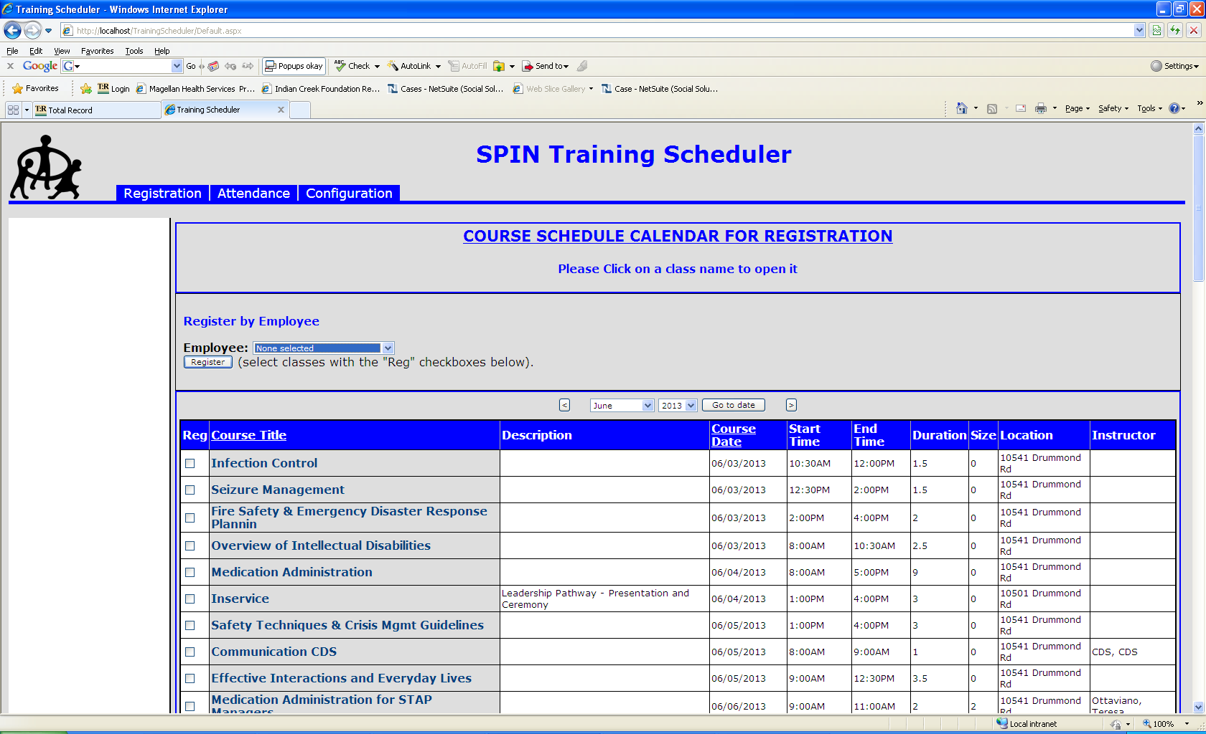

Go to the month that contains the course you want. You do that by clicking the left or right arrows or by selecting the month and year from the drop downs and clicking the go to date button in the date area of the screen.

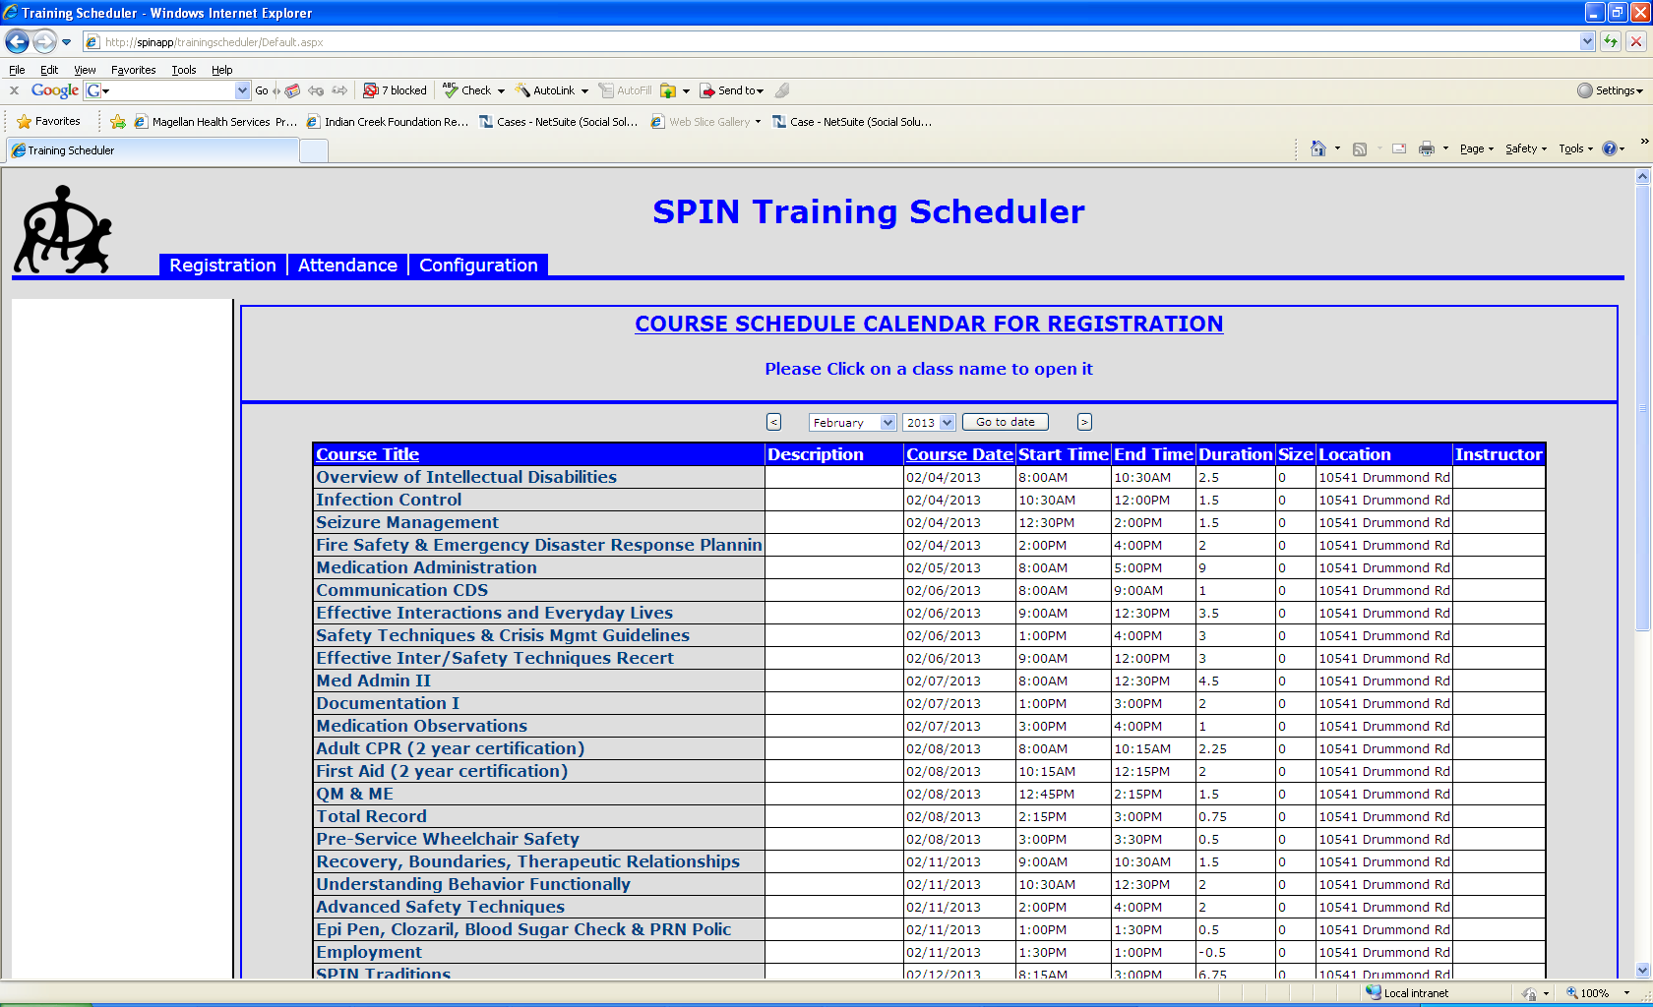

Step 3: With the month selected click on the class that you wish to enroll the employee in. You should now be brought to a screen that looks like this.

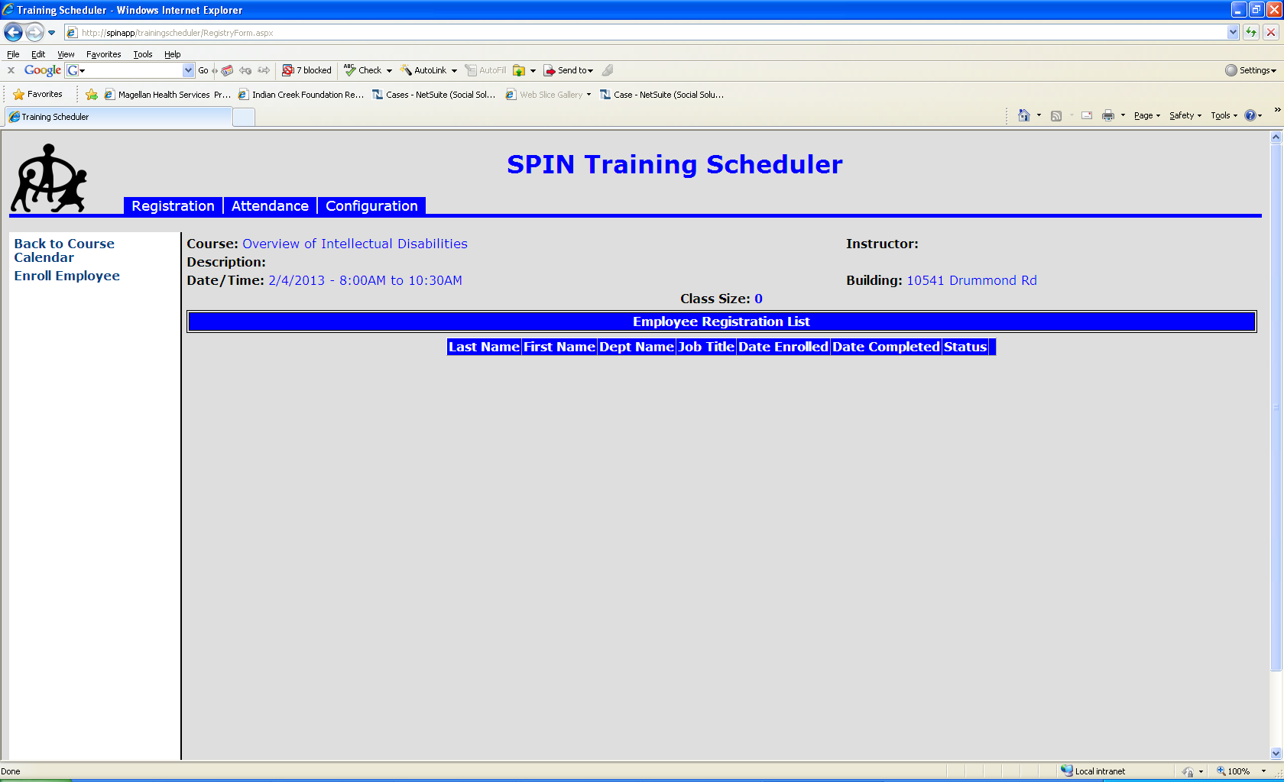

Step 4: Click on the Enroll Employee link on the left hand side of the screen. You should now see a screen that looks like this.

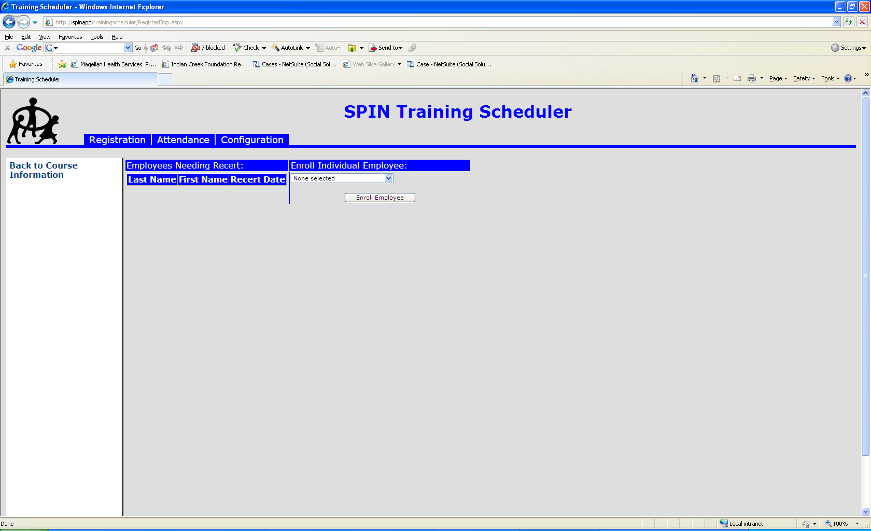

Step 5: If the person needs to a recert in this class there name will appear under the Employees Needing Recert section of the screen. To enroll them just click on their name.

Step 6: If the person does not have a recert date for this class in this month but you still want to enroll them you can do so by selecting their name from the drop down under the Enroll Individual Employee section of the screen.

Step 7: With the employee selected click the **Enroll Employee** button.

Step 8: After an employee has been enrolled by either clicking on their name in the Employees needing Recert section or by selecting their name from the drop down and clicking the **Enroll Employee** button under the Enroll Individual Employee section you should see the following message.

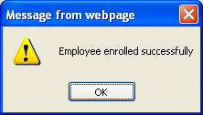

Step 9: Click okay on this message and follow steps 5 thru 8 to enroll the next employee.

Step 10: After enrolling all employees click on the Back to Course Information screen so you can double check the employees you have enrolled.

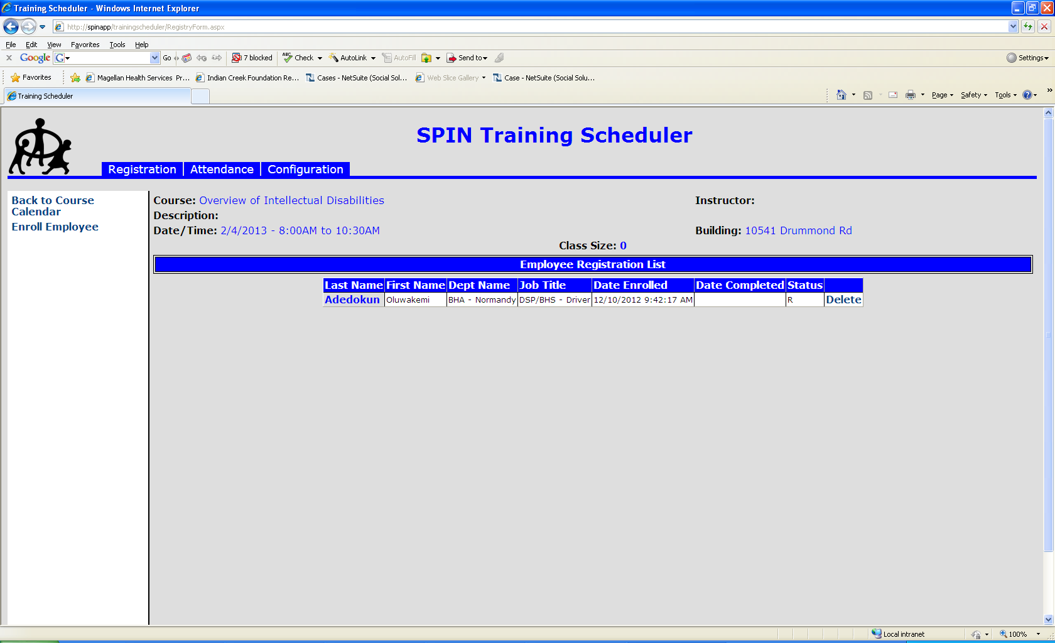

**Enroll an Employee by Employee**

Step 1: Log into Training Scheduler and

Step 2: Once you log on you should see a screen like this



Go to the month that contains the course you want. You do that by clicking the left or right arrows or by selecting the month and year from the drop downs and clicking the go to date button in the date area of the screen.



Step 3: Select an Employee from the Employee drop down



Step 4: Check off all classes in the month that they are registered for.

Step 5: Click the Register Button

